Style Guidelines for Final Year Project ReportsIntelligent AI-Powered HR Recruitment System
Final Year Project Proposal
Session 2022-2026
A project submitted in partial fulfilment of the requirements for the degree
of
Bachelor of Science in Computer Science

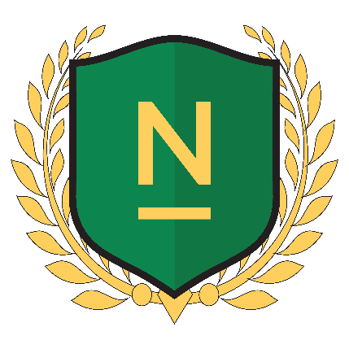

Department of Computer Science
Namal University Mianwali
25 November 2025

Project Registration
Project ID (for office use) |  |  | FYP-CS-01
Type of project |  |  | [ ] Traditional [ ] Industrial [ ] Continuing
Nature of project |  |  | [ ] Development [ ] Research [ ] R&D
Area of specialisation |  |  | Artificial Intelligence
Project Group Members
Sr.# | Reg. # | Student Name |  | CGPA | Email ID | Phone # | Signature
(i) | NUM-BSCS-2022-34 | Zunaira Akbar |  |  | bscs22f34@namal.edu.pk | 03266504297
(ii) | NUM-BSCS-2022-36 | Umair Ahmad |  |  | bscs22f36@namal.edu.pk | 03261218644
Declaration: FYP group members have cleared all prerequisites courses (mentioned below) for FYP-I as per their degree requirements.
(All core courses)
Plagiarism Free Certificate
This is to certify that, I am Umair Ahmad S/D/o Muhammad Ishfaq , group member of FYP under registration no NUM-BSCS-2022-36 at Computer Science Department, Namal University. I declare that my FYP proposal is checked by my supervisor and the similarity index is 7% that is less than 20%, an acceptable limit by HEC. Report is attached herewith as Appendix A.
Date: 8th Oct 2025
Name of Group Member 1: Umair Ahmad Signature: _____________
Name of Group Member 2: Zunaira Akbar Signature: _____________

Name of Supervisor: Mr. Abdul Rafay Signature: _____________
Name of Co Supervisor: Ms. Asiya Batool Signature:____________

Table of Contents

1 Abstract 5
2 Introduction 6
3 Related work 7
4 Project Rationale 8
4.1 Aims and Objectives 9
4.2 Scope of the Project 9
4.3 Success Criterion 9
4.4 Proposed Methodology and Architecture 10
5 Individual Tasks 11
6 Tools and Technologies 12
7 Gantt Chart 13
8 References 14

List of Figures
Figure 1 Workflow Diagram 10
Figure 2 Gantt Chart 13

Abstract
This project provides the idea of an AI-driven HR Recruitment System that automates and simplifies the whole hire life cycle, right from job posting to offer management. Through the use of Natural Language Processing (NLP), machine learning, and workflow automation, the system automatically recruits with smart resume parsing, skill matching, and fit scoring. Some of the key modules are automated job posting, candidate application intake, chatbot-assisted communication, soft skill and personality assessment, and interview scheduling. By combining these intelligent fragments, the system improves candidate match accuracy, reduces manual labor, increases decision transparency, and enables a quicker, more streamlined, and data-driven recruitment process for today's organizations.

Introduction
In today’s hiring process, HR teams often face an overwhelming number of applications and a complex, multi-stage workflow that leads to delays, inefficiencies, and potential human biases. Manually screening CVs, scheduling interviews, and managing offer letters are time-consuming and repetitive tasks. Many organizations store thousands of CVs in their HR systems, and searching through them to find suitable candidates for new roles can be slow and error-prone, sometimes causing qualified applicants to be overlooked [1]. These challenges reduce both the speed and quality of hiring—key factors that directly affect an organization’s growth and competitiveness.
Artificial Intelligence (AI) offers a transformative solution to these challenges by automating and augmenting various stages of the recruitment process. AI-powered tools can streamline repetitive tasks, provide personalized experiences, and offer data-driven insights, thereby enabling HR teams to focus on more strategic initiatives [2]. The proposed Intelligent AI-Powered HR Recruitment System with advanced workflow capabilities aims to address the core inefficiencies in traditional recruitment by developing an advanced system that can intelligently process and match candidate CVs with job descriptions, assess soft skills through AI-driven analysis, Integrated scheduling, and manage the entire offer lifecycle.

This project will focus on designing and developing an AI-powered system that seamlessly integrates with existing HR processes and potentially HRMS. The primary objective is to automate and enhance candidate evaluation across multiple dimensions and streamline the end-to-end recruitment workflow. The system will comprise several key modules, as detailed in the HR system workflow document:

- Job Creation / Posting: Facilitating the creation of job posts with detailed requirements and automated publishing to various platforms.
- Candidate Application Ingestion: Efficiently capturing and processing candidate applications, including resumes and supplementary information.
- Resume Parsing (NLP): Utilizing advanced NLP to extract structured data from unstructured resume text.
- Semantic Matching & Scoring: Utilizing advanced machine learning algorithms to semantically compare candidate skills, experience, and qualifications with job requirements, generating an accurate and data-driven fit score.
- Automated Chatbot API: Providing instant, AI-driven responses to candidate queries, improving candidate experience and reducing HR workload.
- Soft Skill & Personality Analysis: An AI-driven module that analyzes candidates’ video interview responses, including facial expressions, tone, and speech patterns, to assess communication skills, confidence, and personality traits while ensuring fairness and minimizing bias.
- Human Review & Shortlisting: Empowering HR professionals with data-driven insights for informed decision-making in candidate shortlisting.
- Interview Scheduling (Automation): Automating the complex process of scheduling interviews, integrating with calendar systems.
- Decisioning & Offer Management: Streamlining the final stages of recruitment, including offer generation, acceptance tracking, and rejection management.
The main sub-tasks involved in this project include researching and selecting appropriate open-source AI/NLP/Computer Vision models, developing robust algorithms for CV preprocessing and cleaning, building efficient similarity scoring mechanisms, designing and implementing AI models for audio/video analysis, and creating a user-friendly interface for the entire workflow. The success of this project will be measured by its ability to significantly reduce the time and effort involved in recruitment, enhance the accuracy and objectivity of candidate matching and assessment, improve the overall candidate and HR experience, and provide transparent, explainable AI-based decision support—ultimately leading to improved quality of hire and reduced operational costs.

Related work
The integration of Artificial Intelligence (AI) and Natural Language Processing (NLP) into Human Resources (HR) has seen significant advancements, particularly in the domain of recruitment. The primary motivation behind this integration is to enhance efficiency, reduce bias, and improve the overall quality of hire by automating and optimizing various stages of the talent acquisition process [2]. This section provides an analytical review of previous scientific works and current achievements in AI-powered recruitment.
Early applications of AI in recruitment primarily focused on keyword matching and basic rule-based systems for resume screening. However, these methods often lacked the technical depth, intelligence, or robustness to understand the semantic context of job descriptions and CVs, leading to suboptimal matches and the potential exclusion of qualified candidates [3]. The advent of more advanced NLP techniques and machine learning models has revolutionized this landscape.
Natural Language Processing (NLP) in Recruitment: NLP plays a crucial role in parsing and understanding unstructured text data from resumes and job descriptions. Techniques such as tokenization, part-of-speech tagging, named entity recognition (NER), and text classification are employed to extract relevant information like skills, educational qualifications, work experience, and contact details [4]. This structured data then forms the basis for further analysis and matching.
Deep Learning Models for Semantic Matching: The limitations of keyword-based matching have been largely overcome by deep learning models, particularly those based on transformer architectures. Models like BERT (Bidirectional Encoder Representations from Transformers) and Sentence Transformers have emerged as powerful tools for understanding the semantic similarity between texts. BERT, pretrained on a vast corpus of text, can generate contextualized embeddings for words and sentences, allowing for a more optimized understanding of the relationship between a candidate's profile and a job's requirements [5]. Sentence Transformers build upon this by producing dense vector representations for sentences or paragraphs, which can then be used to calculate semantic similarity efficiently. This is particularly useful for tasks such as matching resumes to job descriptions, where the goal is to find candidates whose skills and experience, even if phrased differently, semantically align with the job's demands [6]. Several open-source projects and research initiatives have demonstrated the effectiveness of these models in creating resume matchers and rankers [7] [8]. For instance, platforms like Resume Matcher leverage AI to analyze resume compatibility with Applicant Tracking Systems (ATS) and provide instant match scores and keyword optimization suggestions [9].
Automated CV Screening and Shortlisting: AI systems are now capable of automatically screening thousands of CVs against predefined criteria, significantly reducing the manual effort required. These systems can rank candidates based on relevance, identify key strengths, and even provide explanations for why a particular CV was selected, such as highlighting specific years of experience or matching skills [1]. This automation not only saves time but also increases the accuracy of candidate shortlisting.
AI-Powered Interviewing and Assessment: Beyond initial screening, AI is increasingly used in interviewing and assessment. This includes AI-based audio/video interviewing systems that analyze communication skills, personality traits, and responses through advanced speech and facial expression analysis.
User-Friendly Interfaces and Workflow Automation: Beyond the core matching algorithms, modern AI recruitment systems often incorporate user-friendly dashboards and workflow automation tools. These interfaces allow HR managers to visualize shortlisted candidates, apply additional filters (e.g., by location, graduation year), and gain intelligent insights into candidate profiles. Workflow automation extends to job posting, candidate communication, interview scheduling, and offer management, significantly streamlining the entire recruitment process and enhancing the decision-making process by providing actionable data in an accessible format [2].
In summary, the related work demonstrates a clear trend towards more intelligent, semantic-aware, and automated solutions in HR recruitment, driven by advancements in NLP, deep learning, and workflow automation. The proposed project aims to build upon these foundations, integrating proven techniques and models to create a robust and effective AI-powered HR recruitment system that covers the entire hiring workflow.

Project Rationale
The motivation behind developing an Intelligent AI-Powered HR Recruitment System with advanced workflow capabilities stems from the critical need to address the inefficiencies, limitations, and fragmented nature inherent in traditional recruitment processes. Manual CV screening is not only time-consuming and resource-intensive but also susceptible to human biases and the oversight of potentially strong candidates [1]. Furthermore, the coordination of job postings, candidate communication, interview scheduling, and offer management often involves disparate tools and manual interventions, leading to delays and a suboptimal experience for both HR professionals and candidates. In an increasingly competitive talent market, organizations require agile, effective, and integrated recruitment strategies to secure top talent.
This project is driven by the desire to leverage cutting-edge AI, NLP technologies, and workflow automation to transform HR operations, making them more efficient, accurate, equitable, and streamlined. By automating the initial stages of candidate screening, providing data-driven insights, and integrating end-to-end workflow management, the proposed system aims to empower HR professionals to make more informed decisions, reduce time-to-hire, improve candidate experience, and ultimately enhance the quality of hires. The project also seeks to contribute to the academic understanding and practical application of AI in real-world HR scenarios, particularly in the context of semantic matching, bias reduction, and comprehensive workflow automation.

Aims and Objectives
The goal of the project is to develop an AI-driven HR recruitment system to automate and streamline the entire hiring process, reducing time and cost but improving hiring quality. Its main objectives are:
- To integrate AI and NLP models for intelligent resume parsing, semantic skill matching, and chatbot support, enhancing accuracy and automation in candidate filtering.
- To facilitate the deployment of automated job posting, application processing, interview scheduling, and offer management modules for automating end-to-end recruitment processes.
- To incorporate AI-based audio/video evaluation in evaluating candidates' soft skills and personality traits with fairness and minimizing bias.
- To provide an integrated HR dashboard for real-time data, decision-making, and workflow management to save a significant amount of time, reduce operating expenses, and maximize recruitment efficiency.

Scope of the Project
The project focuses on the development of a comprehensive AI-Powered HR Recruitment System. The scope encompasses the following key functionalities and modules:
- Job Management: Creation, editing, and automated posting of job descriptions to various platforms.
- Candidate Management: Ingestion of applications, resume parsing, and creation of structured candidate profiles.
- AI-Powered Semantic Matching: Semantic matching of candidate profiles against job requirements to generate fit scores.
- Candidate Interaction: An automated chatbot API for answering candidate queries and providing information.
- Assessments: Soft skill and personality analysis through AI-driven video/audio interview.
- HR Workflow Automation: Tools for human review and shortlisting, automated interview scheduling, and decisioning/offer management.

Success Criterion
The success of the Intelligent AI-Powered HR Recruitment System with advanced workflow capabilities will be measured by the following criteria:
- Efficiency Improvement: A measurable reduction (e.g., 30% reduction) in the average time-to-shortlist and time-to-hire, as well as a decrease in manual effort required for administrative tasks.
- Accuracy of Matching: The semantic matching engine should achieve a high precision and recall (e.g., >85% accuracy) in identifying relevant candidates based on job descriptions and HR feedback.
- User Satisfaction: Positive feedback from HR professionals regarding the usability, effectiveness, and decision-support capabilities of the system, measured through user acceptance testing and surveys.
- Workflow Automation: Successful automation of key recruitment stages, including job posting, application ingestion, interview scheduling, and offer management, leading to a smoother and more integrated process.
- System Robustness: The system should be stable, scalable, and capable of handling a significant volume of applications and data processing without performance degradation.
- Data-Driven Insights: The system should provide actionable insights and analytics to HR managers, enabling data-informed decision-making throughout the recruitment funnel.

Proposed Methodology and Architecture
This project will adopt an Incremental model, allowing for iterative development, continuous feedback, and flexibility to adapt to evolving requirements. The development process will involve several sprints, each focusing on specific modules or functionalities. The overall architecture will be modular, leveraging microservices principles to ensure scalability, maintainability, and ease of integration.
Workflow Diagram
The system will be composed of several key components, as illustrated in the workflow diagram below:
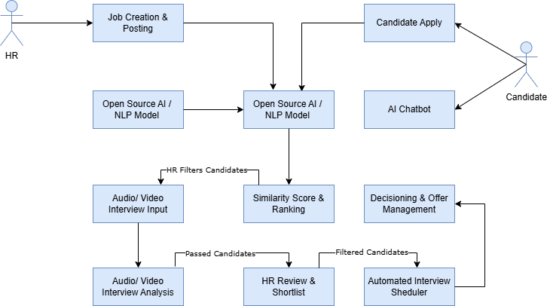
Figure 1 Workflow Diagram

Individual Tasks
This project will be completed by a group of two students: Umair Ahmad and Zunaira Akbar. The tasks will be divided as follows to ensure a balanced workload and effective collaboration:
Team Member | Task / Activity | Tentative Date (by Week & Month)
Umair Ahmad | Project Planning & Proposal Writing | Oct 2025 – Week 1
Umair Ahmad | Literature Review | Oct 2025 – Week 2
Umair Ahmad | Technology Research (AI/NLP tools) | Oct 2025 – Week 3
Umair Ahmad | Finalize Project Scope & Objectives | Oct 2025 – Week 4
Zunaira Akbar | Design System Architecture | Nov 2025 – Week 1
Zunaira Akbar | Design Data Models & Database Schema | Nov 2025 – Week 2
Zunaira Akbar | Set Up Development Environment | Nov 2025 – Week 3
Zunaira Akbar | Git/Version Control Setup & Initial Documentation | Nov 2025 – Week 4
Umair Ahmad | Develop CV/Resume Preprocessing Module | Dec 2025 – Weeks 1–2
Umair Ahmad | Develop JD Preprocessing Module | Dec 2025 – Weeks 3–4
Umair Ahmad | Integrate AI/NLP Models for Semantic Matching | Jan 2026 – Weeks 1–2
Umair Ahmad | Develop Similarity Scoring & Ranking Algorithm | Jan 2026 – Weeks 3–4
Umair Ahmad | Research & Integrate STT and Sentiment Analysis Models | Feb 2026 – Weeks 1–2
Zunaira Akbar | Research & Integrate | Feb 2026 – Weeks 3–4
Umair Ahmad | Implement Facial Expression Recognition Module | Mar 2026 – Weeks 1–2
Zunaira Akbar | Develop & Integrate | Mar 2026 – Weeks 3–4
Zunaira Akbar | Design Frontend UI/UX & Dashboard Layout | Apr 2026 – Week 1
Zunaira Akbar | Develop Frontend Components (Dashboard, User/Admin Views) | Apr 2026 – Weeks 2–3
Umair Ahmad & Zunaira Akbar | Integrate All System Components & Perform Testing | Apr 2026 – Week 4 to May 2026 – Week 1
Both Members | Final Report, Documentation & Presentation Preparation | May 2026 – Week 2 (Before May 18)
Both Members | Final Submission & Project Presentation | May 2026 – Week 3 (By May 20)

Tools and Technologies
To implement the Intelligent AI-Powered HR Recruitment System with advanced workflow capabilities, a combination of robust and scalable tools and technologies will be utilized. The selection prioritizes open-source solutions where possible, ensuring flexibility, cost-effectiveness, and community support.
- Programming Languages & Frameworks: Primarily Python for AI/ML development, complemented by a Python web framework (e.g., Flask/Django) for backend services and a modern JavaScript framework (e.g., React/Angular/Vue.js) for the interactive frontend.
- Artificial Intelligence & Machine Learning Libraries: Key libraries will include Hugging Face Transformers for advanced NLP (resume parsing, semantic matching), along with foundational NLP tools (SpaCy/NLTK) and deep learning frameworks (TensorFlow/PyTorch) for model development and deployment. OpenCV may be used for computer vision aspects in soft skill analysis.
- Database & Storage: A robust database solution (e.g., PostgreSQL/MongoDB) will store structured data, while S3-compatible object storage will handle raw files like resumes and multimedia recordings.
- Workflow & Integration Tools: RESTful APIs will facilitate communication between microservices and external platforms. Message queues (e.g., RabbitMQ) will manage asynchronous tasks, and specific APIs will be used for calendar integration (Google/Outlook) and external job board posting.
- Development & Deployment Tools: Git for version control, Docker/Kubernetes for containerization and orchestration, and a Cloud Platform (e.g., AWS, GCP, Azure) for hosting and scalability. Jupyter Notebooks will support prototyping.
- Chatbot API Framework: A dedicated chatbot framework (e.g., Rasa/Dialogflow) or custom LLM integration will power the automated candidate interaction module.

Gantt Chart
The following Gantt chart provides a visual representation of the project timeline and key milestones:
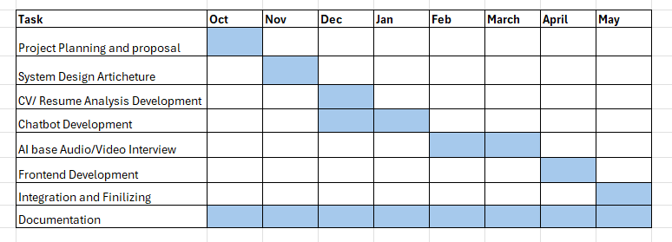
Figure 2 Gantt Chart

References
[1] P. K. Singh, S. Singh, and R. Singh, “A survey on AI based recruitment system,” in Proc. 5th Int. Conf. Computing, Communication and Automation (ICCCA), 2020, pp. 396–401.
[2] H. A. Al-Ajmi, “Artificial intelligence in human resources management: A review,” Int. J. Comput. Sci. Netw. Secur., vol. 21, no. 1, pp. 165–171, 2021.
[3] J. Smith, “The evolution of AI in recruitment: From keyword matching to semantic understanding,” J. HR Technol., vol. 15, no. 2, pp. 45–58, 2018.
[4] A. K. Singh and S. Kumar, “NLP-based resume parsing for recruitment system,” in Proc. Int. Conf. Mach. Learn., Big Data, Cloud and Parallel Computing (COMITCon), 2019, pp. 234–239.
[5] J. Devlin, M.-W. Chang, K. Lee, and K. Toutanova, “BERT: Pre-training of deep bidirectional transformers for language understanding,” in Proc. 2019 Conf. North Amer. Chapter Assoc. Comput. Linguistics: Human Lang. Technol. (NAACL-HLT), vol. 1, 2019, pp. 4171–4186.
[6] N. Reimers and I. Gurevych, “Sentence-BERT: Sentence embeddings using Siamese BERT-networks,” in Proc. 2019 Conf. Empirical Methods Natural Lang. Process. and 9th Int. Joint Conf. Natural Lang. Process. (EMNLP-IJCNLP), 2019, pp. 3981–3990.
[7] A. Sharma, S. Gupta, and P. Kumar, “AI-powered resume matcher: A deep learning approach,” Int. J. Adv. Res. Comput. Sci. Softw. Eng., vol. 9, no. 5, pp. 10–15, 2019.
[8] R. Kumar and S. Singh, “A smart recruitment system using machine learning and natural language processing,” in Proc. 5th Int. Conf. Computing, Communication and Automation (ICCCA), 2020, pp. 396–401.
[9] Resume Matcher: AI Resume Checker & ATS Scanner. [Online]. Available: https://resumematcher.com/

